Noor ul Ain  
Dr. Kaveri Qureshi  
ANTH 292  
8th May 2017  
 Redefining Disruption: Illness and the Metaphors of Arts  
 Perhaps, it is the most basic human instinct to try to make meaning out of chaos—to turn pain into something productive, to weave tales from tragedy, and even to sooth the battle inside one’s body by turning it into art. These forms of expression at times just come from a desperate human need to understand whatever event or circumstance one is trying to brave. Illness may be labeled as one of the most prevalent and insidious form of disruption of daily life and perhaps hence, has produced a wide array of attempts to curb its chaos. Gay Backer, in her book *Disrupted Lives: How People Create Meaning in a Chaotic World* explores this very idea of people’s attempts to form meaning after they encounter disruptions, whether “societal… or individual, such as the onset of illness”, people try to regain the routine or linearity of their disrupted lives (4). This paper will attempt to look at a similar concept: the place of performance and art (visual, mixed media) as a means of making meaning out of illness and gaining control of bodies that are deteriorating.  
 Simple routines, such as having coffee in the morning or brushing teeth at night, create a sense of familiarity with one’s life and the world at large. Illness becomes a form of disruption that begins to impede on basic expectations of how a life is supposed to be lived. For this reason, perhaps, people racked with illness crave continuity. Becker shows how regaining this “mundane and comforting sameness of repetitive activities” becomes a necessary attempt at redefining the disruption and understanding the self and world in light of this change (4). To regain this continuity, however, the human body needs to be understood as a culmination of a person’s past, present and future experiences with illness—it acts as a reservoir of memory. Furthermore, while the body may be a site for a person’s experiences with distress, it may also be the very medium used for creating meaning. Performance or visual art takes the performativity involved with illness, whether it is “the nurses’ inquiry about bowel movement, the obstetrician’s or midwife’s praise in the labor ward” or even the physical decline of one’s own body, and translates it into work that narrates the illness experience and simultaneously, reconciles the artists memory of that experience (Frankenberg 622).   
 To set this idea of reconciliation and reconstruction of identity into context, let us take the example of Donald Rodney, a British artist who in his short life suffered from sickle-cell anemia. About a year before his death, Rodney produced a work entitled *In the House of My Father* (1996-7) which is a photograph of a close up of Rodney’s hand, on which lies a miniature sculpture of a house made of human skin. This house, held together by a pin, is made up of Rodney’s own skin that was removed during the many operations he had to control his disease. It is interesting to note that sickle cell anemia is an inherited disease that is largely prevalent in African, Caribbean, Eastern Mediterranean, Middle Eastern and Asian ancestry (Barson 2002). Through his works, and especially the one aforementioned, Rodney attempts to understand his identity as a Jamaican-British artist who is living in a time that is infused with racism. Through his work, Rodney makes his disease a metaphor for what he believes is the “diseased British society” (Lack 2008). But *In the House of My Father* specifically, lends itself to more than just a metaphoric status—it embodies Rodney’s association with his diseased body and the acknowledgment of its frailty and vulnerability. The small, fragile house of skin symbolizes “the near-futility of Rodney having to live within a structure hopelessly unable to sustain itself”—the idea of his body as a safe haven and his skin as a protector has dramatically changed, leaving only metaphors and symbols to remember it by (Barson 2002). Another interesting element of Rodney’s work is the use of photographs and mixed media installations that symbolize the endless hospital visits, x-rays, tests and scans that defined Rodney’s life. Through the use of photos, Rodney documents his personal experience of his illness much like the tests, scans and reports document the formalized/institutionalized side of his illness. Through delineating a trajectory of his identity, Rodney was able to combine the social and personal reality of his sickness, simultaneously intending references “to medicine and the body to refer metaphorically to social sicknesses, including racism, police brutality or apartheid, as much as to his personal circumstances” (Barson 2002).   
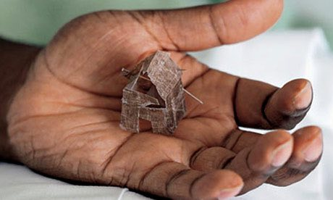  
 In the same stream, Ronald Frankenberg in his essay “Sickness as Cultural Performance: Drama, Trajectory, and Pilgrimage Root Metaphors and the Making Social of Disease” expands on Susan Sontag’s ideas of disease as a metaphor. Sontag relates an idea similar to what Rodney explores with his work: “a major part of the experience of being ill is, in fact, to experience at second hand the disease of the doctors and the structured metaphorical sickness of social forms” (607). The idea is that to fully understand a personal crisis, it is often given a metaphoric treatment so as to transcend the level of the individual and become a social phenomenon Sontag explains: “what cannot be avoided is made metaphorical” (608). Frankenberg’s contentions, then, lie with the way treatments for sickness are often sought in formalized medicine. He claims that common-sense entails solutions, for social or personal ills, to be looked for and found in “physical manipulation” (technology, chemotherapy, surgery) or in “biological regimens” (exercise, lifestyle cleansing) rather than “in changes in social relationships” (603). There is, however, a possibility to combine these two seemingly contradictory ways of understanding sickness (art and/or technology) which an American Visual Artist & Technologist, Justus Harris, aims to do.  
 Harris was diagnosed with type 1 diabetes at age 14 and spent ample time in his childhood looking at graphs and medical data in an attempt to understand his illness. He realized as an adult, while discovering the world of art that he could attempt to understand and communicate through visual art. Hence, Harris creates 3D sculptures of blood glucose data, as visualizations or tangible forms of his medical reports that he can hold in his hands and physically understand. Much like Rodney, the experience of understanding his body comes from translating medical data into a personal tale of symbols and metaphors that narrate his experience with his illness and his identification with his own self. Harris notes that for him being a Visual Artist & Technologist “entails understanding the medical technology (he) cares about and its social and experiential contexts” and also “using (his) skills as an artist to improve upon and reflect on how people use technology in their life, whether to treat an illness or form relationships” (Tenderich 2015). From a perversion that is happening inside a body or mere statistics and numbers written on paper, performing art makes an illness visual and tangible—expanding the boundaries of how an illness can be experienced and how it can be expressed.   
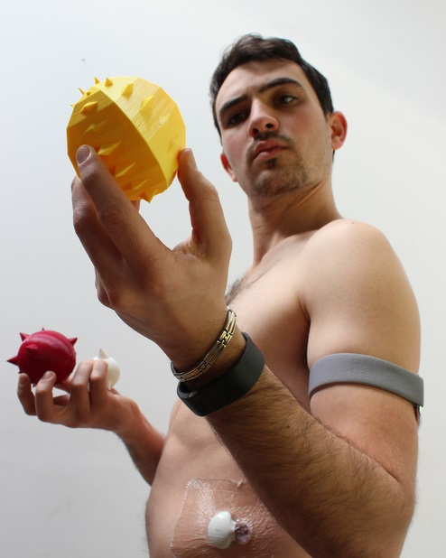  
 With the acknowledgement of performing arts as a form of redefining disruption, there is also the idea of ethnography as performance. This concept is bought forth in Andrew Irving’s essay “Ethnography, Art and Death” where the author narrates several experiences of people with HIV in Kampala, Uganda. Around 10% of all people in Kampala suffer from HIV/AIDS, hence, the landscape of the city itself is largely marred by disease. Therefore, the method Irving uses to document the illness narratives of the people he interviews is to create a sort of “map” of Kampala that is based off emotional memory and experience rather than roads, buildings and numbers. The idea is to see the individual as part of a landscape which is intimately informed by experiences of illness, disease and death. In such a case, the field becomes a stage, the participants as performers and the ethnographer as a director/writer. To take one example, Daniel Kafeero is one of the people interviewed, who was diagnosed with HIV in 1997. Irving and Kafeero walk through Kampala with a tape recorder, in which Kafeero narrates his thoughts and memories associated with the places they pass and Irving interjects with questions and documents through photographs. The idea of this performativity as a way to narrate illness is to show how memory is produced through performance—therefore, “what emerges is a tangible, although fragmentary, sense of living in contemporary Africa amidst HIV that opens up the city for the audience, rather than fixing it through explanation” (Irving 193). Irving views the neighborhood as such an entity as well: one that is as contagious as memory or disease—one that is passed on and shared and hence, enables people such a Kafeero to form their own experiences of illness by travelling through this neighborhood.  
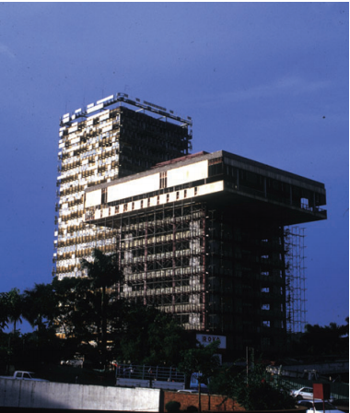  
 Another essential idea connected with walking through the space of the neighborhood and evoking memories related to each location, is using the metaphor of walking as “a creative intentionality that allows people’s walking practices to redefine the existential experience of illness in the present” (194). Hence, Daniel Kafeero, for example, can redefine his illness and the experience of it by actively avoiding locations in the city that bring back memories of suffering (as when he was contemplating suicide). Through this blurring of ethnography and performance, the diseased body and its relationship with the neighborhood is understood as a way of redefining the experience of illness and simultaneously, expressing and attempting to control the agonizing memory of it. A visual artist deeply acquainted with the personal suffering of HIV and also the loss of loved ones due to it, is Felix Gonzalez-Torres, a Puerto Rican- American artist known for his quiet minimalistic installations.   
 Gonzalez-Torres worked with simple everyday objects such as strings of light bulbs, clocks, stacks of paper, beads, or wrapped hard candies, but turned these simple objects into metaphors that speak the language of love and loss, of sickness and rejuvenation, and often, gender and sexuality. His work is said to be a reflection of his experiences with HIV, and much like Irving’s idea of performative ethnography, Gonzalez-Torres invites his audience to participate in his work. To take an example of his work, let us look at *"Untitled" (Portrait of Ross in L.A.),* made in 1991. Ross Laycock was the artist’s lover who died from an HIV related disease the same year; his portrait, hence, is a pile of multicolored individually wrapped candies weighing the same amount as Ross’s body weight, these Gonzalez-Torres piles in a corner of the gallery. The gallery-goers are invited to eat the candy and once it finishes, it is replaced to its original weight. This allegorical portrait made from a diminishing amount of candy “symbolically refers to Laycock’s body languishing from disease” (Storr 11). Most of the materials he uses are not known for their permanence, candies are eaten, light bulbs fuse, paper is used up or torn, suggesting, perhaps, a metaphor of death in his works. However, it is also interesting to note that the artists makes sure that his work survives, all these objects are such that they can be replaced or regenerated (bulbs replaced, candies replenished), putting forth an idea that this work can also simultaneously be about life. Lastly, Gonzalez-Torres used his work not just as a personal anecdote of illness and loss (which is what it largely became after the death of Ross) but also as a politically charged metaphor for the “sociopolitical tensions from the queer community” and the “inaction of the government” regarding basic rights and the spread of disease that took many included Ross and later, Gonzales-Toress himself at the age of 38 (Diamond 5). The artist, in his own words, noted “that (he) wanted to make art work that could disappear, that never existed, and it (would be a) metaphor for when Ross was dying. So it was a metaphor that (he) would abandon this work before this work abandoned (him)… going to destroy it before it destroys (him)” (Storr 11).   
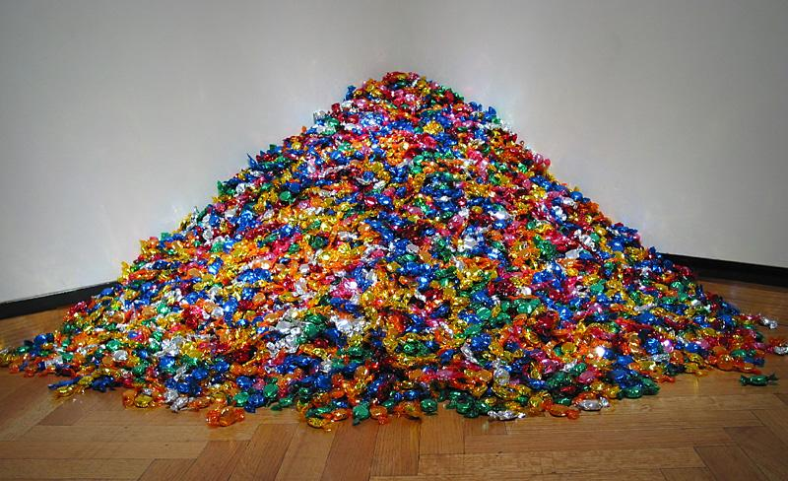  
 In conclusion, in the prophetic words of the American composer and lyricist Stephen Sondheim: “Art, in itself, is an attempt to bring order out of chaos”. All forms of art, it may be argued, come as some sort of catharsis, but the idea of performativity and performative art lends another layer to this idea of expression. Performance, as Victor Turner might argue, is deeply connected to the idea of illness and hence, using that as a form of reconciliation only makes sense. This paper has attempted to flesh out the idea of understanding diseased bodies, reconciling the illness experience and ultimately redefining the disruption that has curbed continuity. Going beyond the world of statistics, data and percentages, illness is attempted to be understood by each artist through means that translate the illness into metaphors of personal suffering and simultaneously, societal relationships. By making a disease into a tangible entity—that can be held as a house of skin or sculpted into 3D data or narrated through a walk in the neighborhood or eaten like candy much like a disease eats the body—visual, performance and mixed media art allows wonders to emerge from processes that are disruptive, perverse and painful in the hopes of gaining some sort of control over the experience of illness.   
.

“Then another time I went to see someone who worked at The Crested Towers ... and I thought I could climb the Crested Towers or the highest building and drop. I hated everyone except my five children ... I had no money, no food, no land, no work and I thought we will live just like gorillas in the bush. I felt very sick and weak and so I didn’t climb the building but continued walking round Kampala looking for another building to drop from but was not so high. I walked around and around town and people would stare but I did not care because I was in a world of my own.”

Works Cited

Barson, Tanya. "In the House of My Father, Donald Rodney 1996-7." *Tate*. N.p., Feb. 2002.

Becker, Gay. "Disrupted Lives: How People Create Meaning in a Chaotic World." *Google Books*. University of California Press, 1998.

Diamond, Shawn. "requiem for the shadows: poetry, spirituality, and future memory in the light strings of felix gonzalez-torres." College of the Arts of Kent State University, May 2016.

Frankenberg, Ronald. "sickness as cultural performance: drama, trajectory, and pilgrimage root metaphors and the making social of disease." *SAGE Journals*. Original Articles on Medical Anthropology, 1986.

Irving, Andrew. "Ethnography, Art, and Death." *Journal of the Royal Anthropological Institute*. Blackwell Publishing Ltd, 08 Feb. 2007.

Lack, Jessica. "Artists of the Week 17: Donald Rodney." *The Guardian*. Guardian News and Media, 26 Nov. 2008.

Storr, Robert. "Felix Gonzalez-Torres." *Choice Reviews Online* 44.06 (2007).

Tenderich, Amy. "Meet the King of 3D Blood Glucose Sculptures." *Healthline*. Healthline Media, 19 Oct. 2015.